IGA Diploma in Groupwork Practice (York) – Foundation Year 2021-22 Intake

offered by:

Please affix photo here
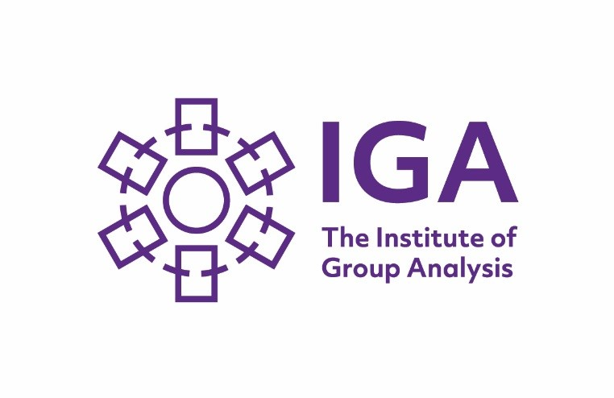

in conjunction
with

York Groupwork Ltd. The Institute of Group Analysis

Name: |  | Date of Birth:
Home Address:  Postcode: | If employed, Work Address:  Postcode:
Home Telephone: | Work Telephone:
Mobile: | Home email address:
Job Title and occupation: | Work email address:
Brief details of previous any personal therapeutic experience (individual or group):

Brief details of any group you are facilitating currently or planning to run (this is not a course requirement):

If you wish, write briefly about why you are applying for the course and what you hope to gain from it:

Please return the completed application form along with the non-refundable registration fee of £250.00 and a small passport size photograph, to 31 St Paul’s Square, York, YO24 4BD.

Payment methods:

Please make cheques payable to York Groupwork Ltd.

To pay by electronic transfer of funds, contact us via admin@yorkgroupwork.com for bank details.

For organisationally funded places, if you would like us to invoice the organisation for your registration fee, please provide a purchase order and/or written confirmation by the employer of your place booking.

Please read our cancellation policy. When we confirm your place, we will send you further information about arrangements for payment of the remainder of the course fee.

Applicant’s signature:
Date:

When you have sent in this form, please also register as a student member of the IGA at www.groupanalysis.org/Training/NationalFoundationCourseinGroupAnalysis/York . This is a simple process, involving no payment, which will take only a few minutes. It will give you access to the IGA’s facilities and virtual learning environment.

Please tick this box if you would like to be added to our mailing list to receive information about our other courses and workshops:

Registered company number 06728779 (England and Wales).
Registered office: 2 Clifton Moor Business Village, James Nicholson Link, York YO30 4XG

