IGA Diploma in Groupwork Practice (York) – Diploma Year 2021-22 Intake
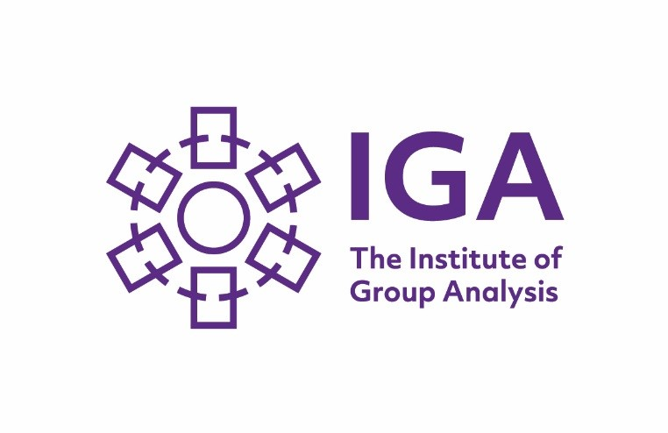

Please affix photo here

York Groupwork Ltd. in conjunction with The Institute of Group Analysis

Name: |  | Date of birth:
Home Address:  Postcode: | Work Address:  Postcode:
Home Telephone: | Work Telephone:
Mobile: | Email:
Job Title and Occupation: | Work Location: (e.g. hospital, psychology department, school, etc.)
Education
Please tick the appropriate box to describe your highest educational level, up till now:

GCSEs □ A Levels/BTEC □ Undergraduate degree □ Postgraduate level □

Subject(s) studied at degree level or above:

Other (please describe)
Have you completed an Institute of Group Analysis (IGA) introductory/foundation course?
- No
- Yes
Please specify which venue and the year undertaken. If you have not completed an IGA course, you will need to apply under the IGA’s accredited prior learning route. In this event, please consult the course convenor before applying.

Name of experiential group conductor

Previous Experience
Are you currently running a group?
- Yes
- No

If you are currently running a group, briefly describe this group and the supervision you receive for it

Trainees are asked to bring a group to discuss as part of the Diploma in Groupwork Practice. A wide variety of different groups can be considered (including a new group you may wish to set up), but you are asked to discuss this with the Course Convenor before submitting your application. Please describe briefly below what you intend to bring:

Please describe how you expect this course to further your professional development and also how you expect it to further your personal development. (Maximum 500 words – continue overleaf if necessary)

Are you in therapy currently?  - Yes No  If yes, please give type and frequency of therapy:  Would you like to have a consultation with a group conductor from one of the block therapy group that meets on the Saturdays after the course days?  (An additional consultation fee of £80 is payable).  - Yes No | Do you plan on attending another course in the next year?  - No  - Yes  If yes, please describe it briefly:
How did you hear about this course?  - Leaflet / Poster  - Other advertisement  - Word of mouth  - York Groupwork Ltd. Website  - IGA Website  - Other (please specify) | You will have an interview in York with a panel including course staff and an external group analyst, which will last up to an hour. Those interested in a block therapy group will also have a consultation with the group conductor. Wherever possible, these will be arranged to take place on the same day.  Please provide any dates when you will NOT be available.  ______________________________________________
Referee (Professional)

May we take up this reference prior to your interview: Yes □ No □
Applicant’s signature:________________________________________Date:_________________________
Please return the completed application form along with the non-refundable registration fee of £250.00 and a small passport size photograph, to 31 St Paul’s Square, York, YO24 4BD.

Payment methods:
Please make cheques payable to York Groupwork Ltd.

To pay by electronic transfer of funds, contact us via admin@yorkgroupwork.com for bank details.

For organisationally funded places, if you would like us to invoice the organisation for your registration fee, please provide a purchase order and/or written confirmation by the employer of your place booking.

Please read our cancellation policy. When we confirm your place, we will send you further information about arrangements for payment of the remainder of the course fee.

Please tick this box if you would like to be added to our mailing list to receive information about our other courses and workshops:

Registered company number 06728779 (England and Wales).
Registered office: 2 Clifton Moor Business Village, James Nicholson Link, York YO30 4XG

